**TO HANDLE MULTIPLE FRAMES**

**CODE:**

**package** july17;

**import** java.io.IOException;

**import** java.util.List;

**import** org.openqa.selenium.By;

**import** org.openqa.selenium.WebDriver;

**import** org.openqa.selenium.WebElement;

**import** org.openqa.selenium.chrome.ChromeDriver;

**public** **class** FrameHandling{

**public** **static** **void** main(String args[]) **throws** IOException, InterruptedException

{

System.*setProperty*("webdriver.chrome.driver","C:\\Program Files\\Java\\jdk1.8.0_131\\chromedriver.exe");

WebDriver wd=**new** ChromeDriver();

wd.get("http://www.dailythanthi.com/");

WebElement f1=wd.findElement(By.*name*("google_ads_iframe_/118893066/dailythanthi//homepage_5"));

System.***out***.println(f1);

WebElement f2=wd.findElement(By.*name*("google_osd_static_frame"));

System.***out***.println(f2);

Thread.*sleep*(2000);

/*WebElement f3=wd.findElement(By.id("ebBannerIFrame_46526137_47813195962113264"));

System.out.println(f3);

Thread.sleep(2000);*/

wd.switchTo().frame(f2);

//wd.switchTo().defaultContent();

wd.findElement(By.*xpath*(".//*[@id='TopHead']/a[1]/img")).click();

Thread.*sleep*(2000);

//wd.switchTo().frame(f);

wd.findElement(By.*xpath*(".//*[@id='TopHead']/a[2]/img")).click();

}

}

**OUTPUT:**

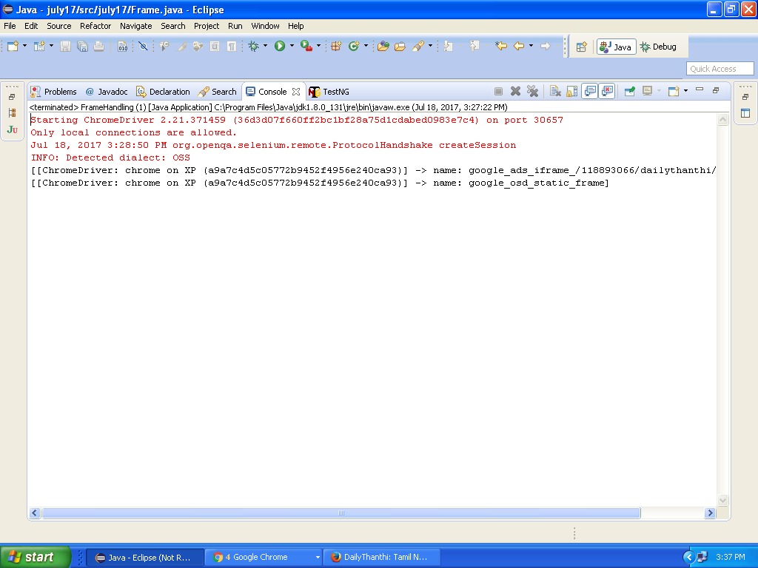

**TO HANDLE MULTIPLE WINDOWS**

**CODE:**

package july17;

import java.util.Iterator;

import java.util.Set;

import java.util.concurrent.TimeUnit;

import org.openqa.selenium.By;

import org.openqa.selenium.WebDriver;

import org.openqa.selenium.chrome.ChromeDriver;

public class Frame {

public static void main(String args[]) throws InterruptedException

{

System.setProperty("webdriver.chrome.driver","C:\\Program Files\\Java\\jdk1.8.0_131\\chromedriver.exe");

WebDriver wd=new ChromeDriver();

wd.manage().window().maximize();

wd.manage().timeouts().implicitlyWait(10, TimeUnit.SECONDS);

wd.get("https://www.naukri.com/");

wd.findElement(By.xpath("html/body/div[2]/div/ul/li[2]/a/div")).click();

Set<String> winlist=wd.getWindowHandles();

System.out.println("No of windows:"+winlist.size());

Iterator it=winlist.iterator();

System.out.println(it.next());

System.out.println("------------------------");

Thread.sleep(2000);

winlist=wd.getWindowHandles();

System.out.println("No of windows:"+winlist.size());

it=winlist.iterator();

String mainwin=(String) it.next();

String popupwin=(String) it.next();

System.out.println(it.next());

System.out.println(mainwin);

System.out.println(popupwin);

wd.switchTo().window(popupwin);

wd.findElement(By.xpath(".//*[@id='skill']/div[1]/div[2]/input")).sendKeys("java");

wd.findElement(By.xpath(".//*[@id='location']/div[1]/div[2]/input")).sendKeys("chennai");

wd.findElement(By.xpath(".//*[@id='qsbFormBtn']")).click();

Thread.sleep(2000);

wd.close();

wd.switchTo().window(mainwin);

wd.close();

}

}

**OUTPUT:**

